Name：Eman Fatima
Reg No: BSSE-23S-0025
Program: BSSE
Date: September 16th, 2026

WEEK NO. 5-

PART A: EMBEDDINGS FUNDAMENTALS

Exercises:-

Compare Similar and Unrelated Meaning
Code:
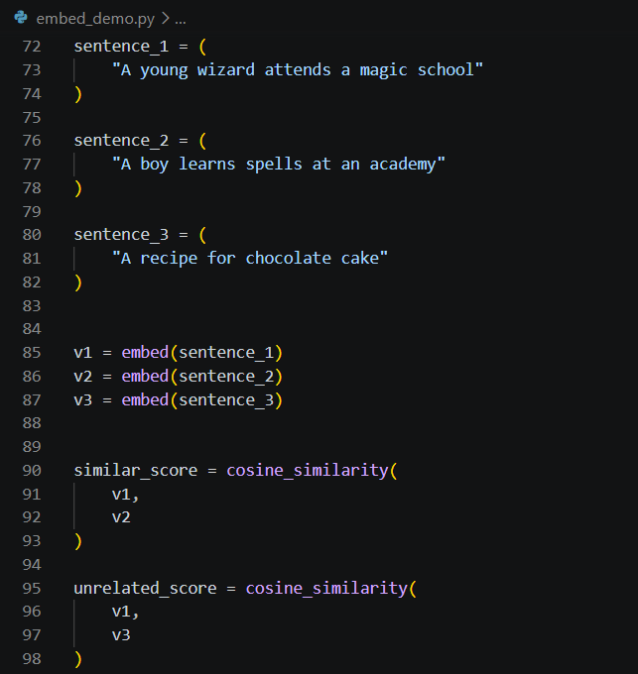
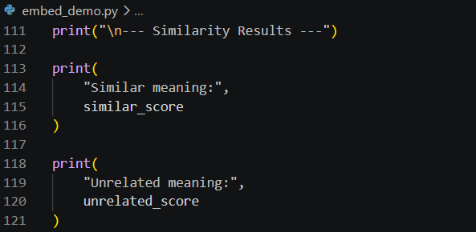
Output:
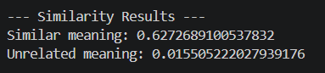

Inspect the Embedding Vector
Code:
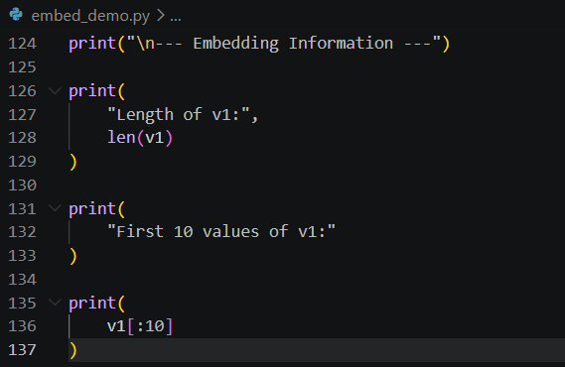
Output:
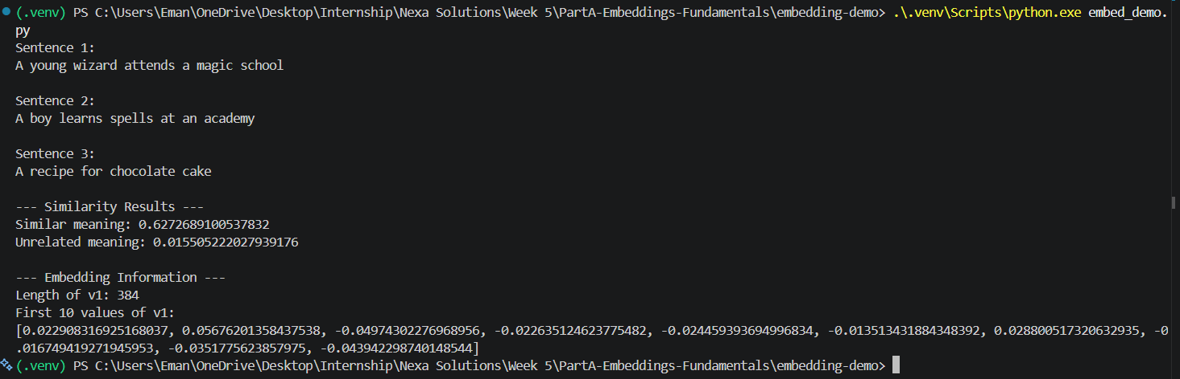

Similar Words but Opposite Meaning
Code:
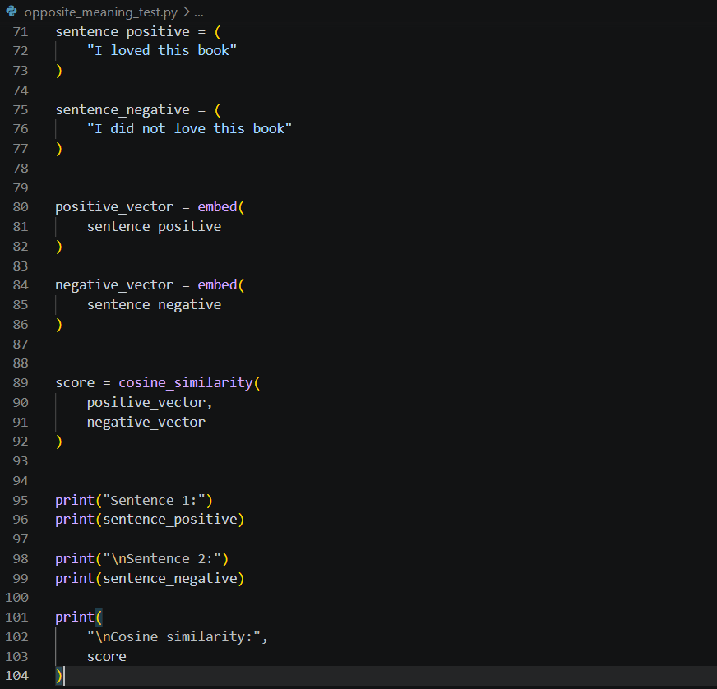
Output:
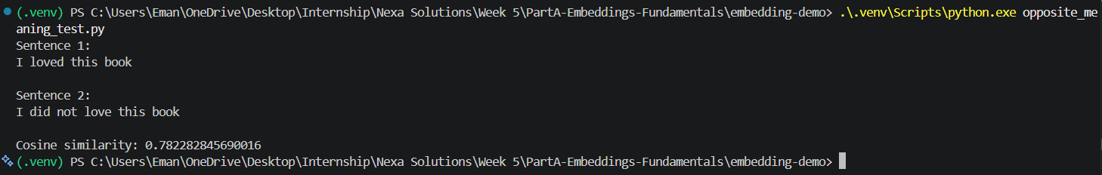

PART B: VECTOR DATABASES

Exercises:-

Confirm Space Query Returns Science Fiction First
Code:
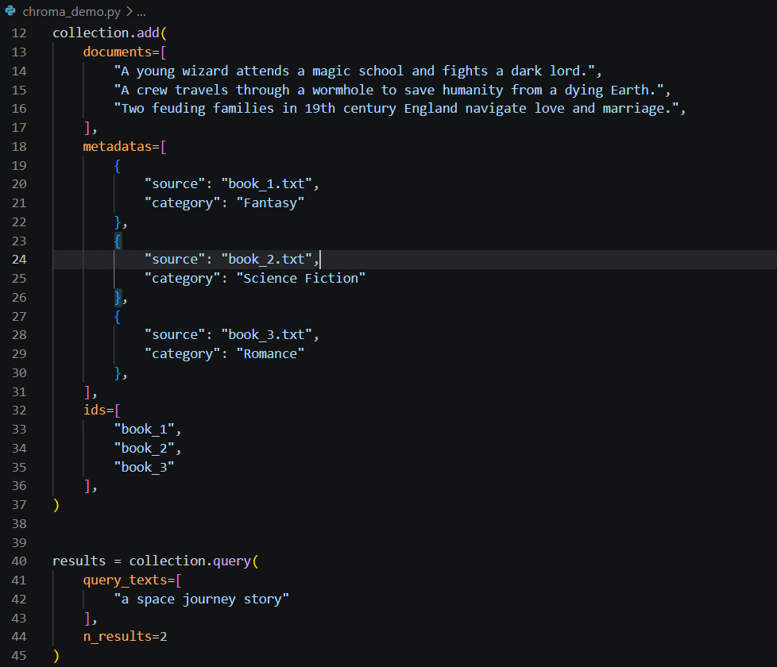
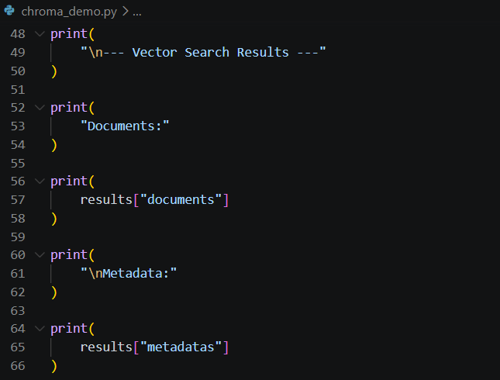
Output:
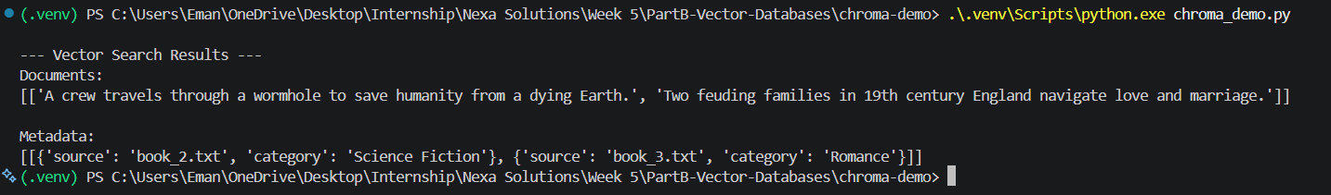

Metadata Filtering in Chroma
Code:
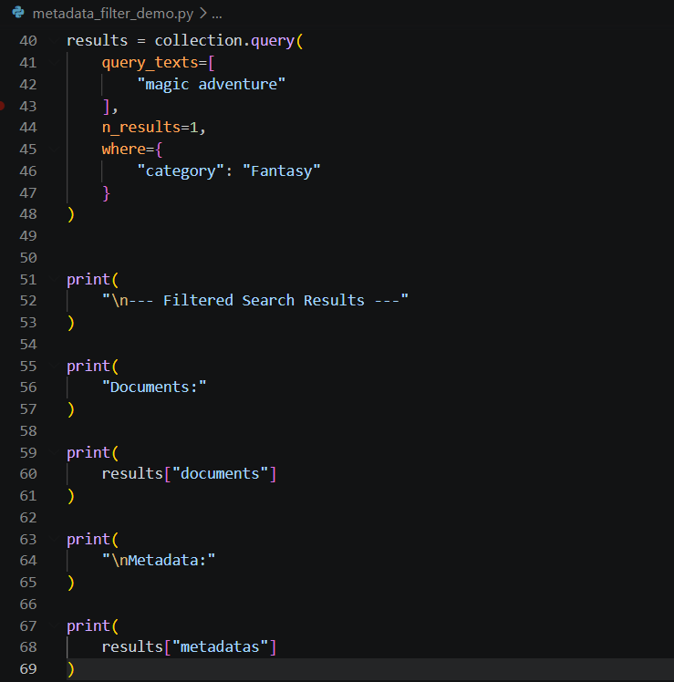
Output:
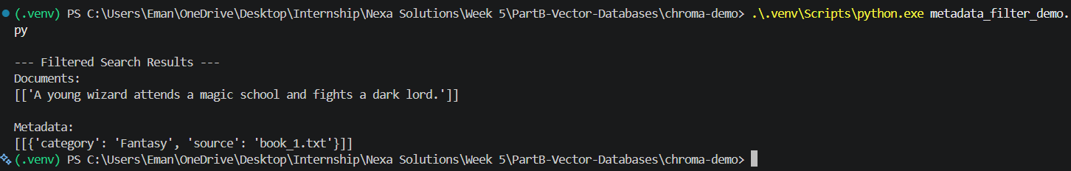

Adding More Documents and Repeating Vector Searches
Code:
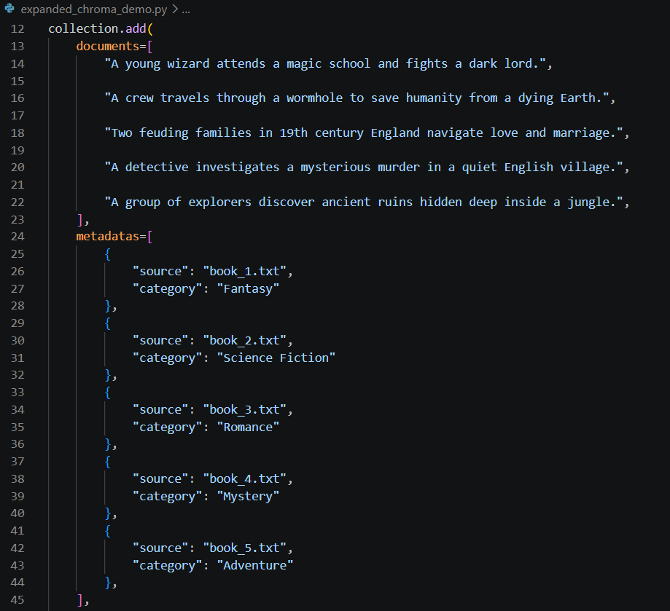
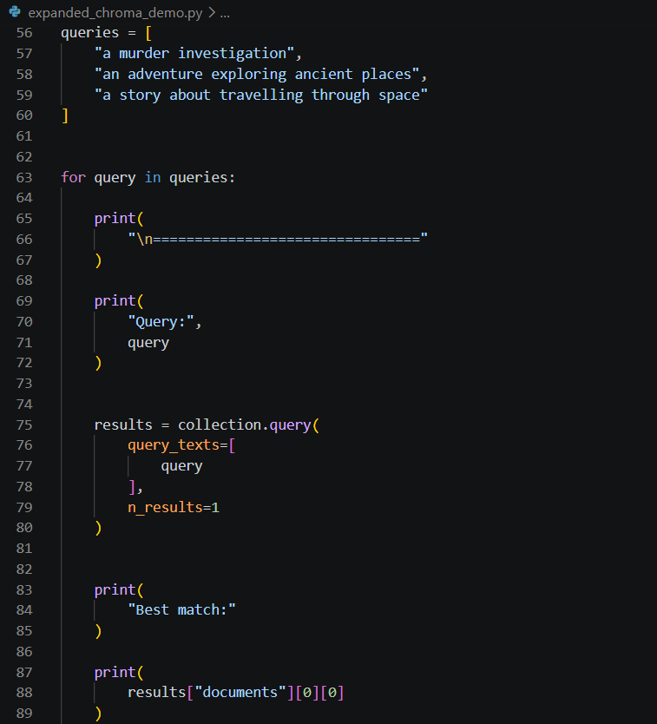
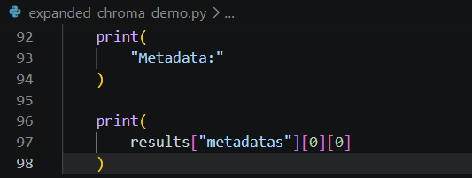
Output:
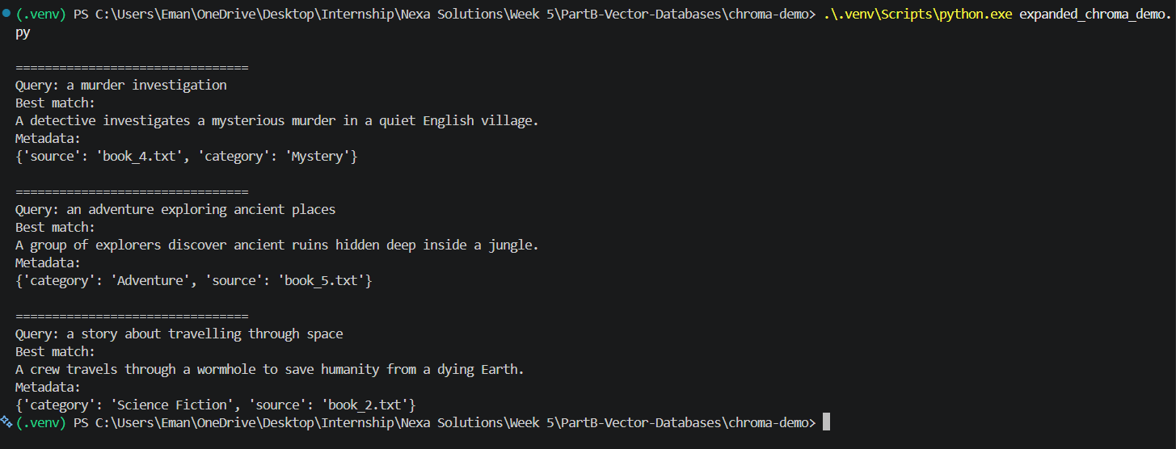

PART C: RAG FUNDAMENTALS: BUILDING THE PIPELINE BY HAND

Exercises:-

Add 3–4 Documents Using add_document()
Code:
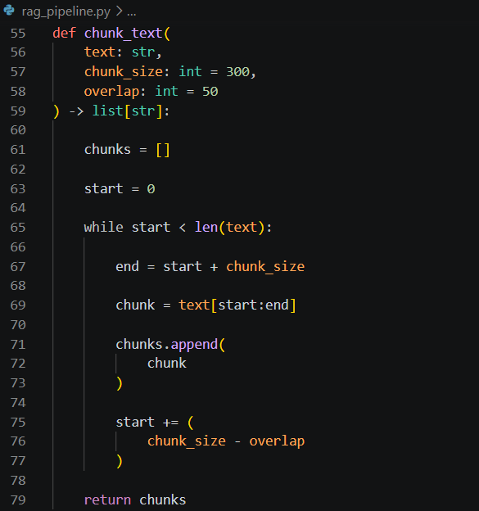
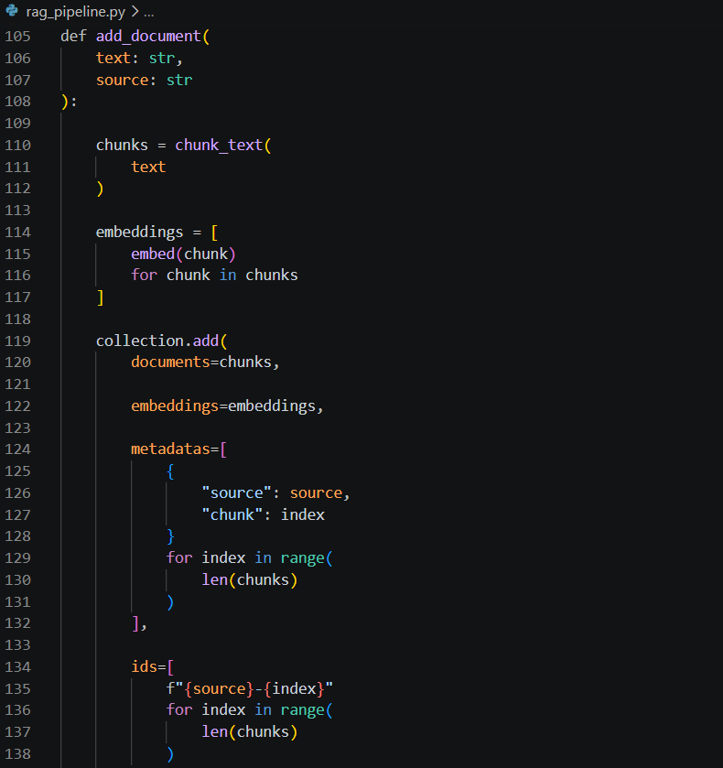
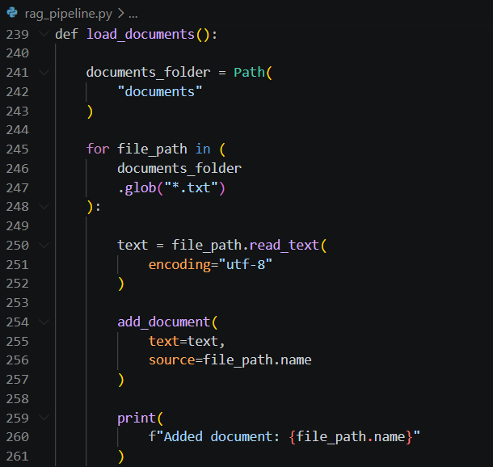
Output:

Ask an Answerable Question
Code:
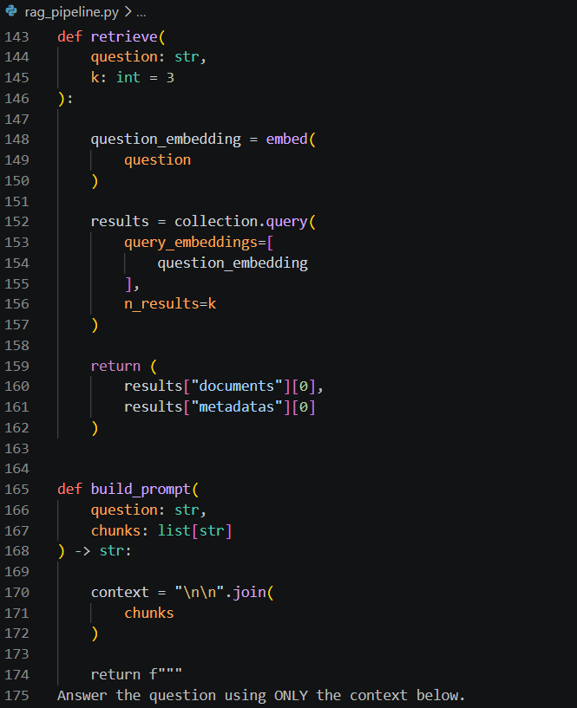
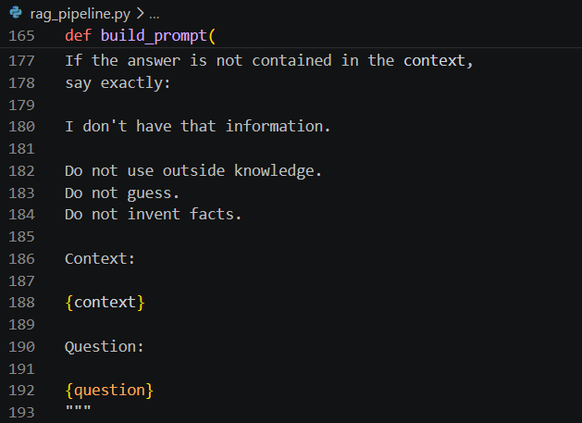
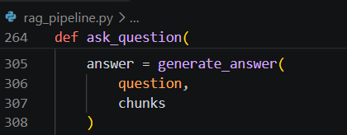
Output:
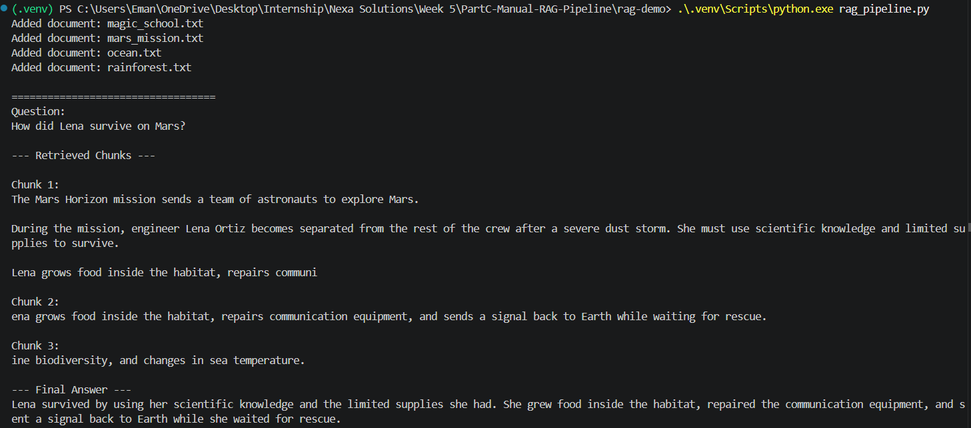

Ask an Unrelated Question
Code:
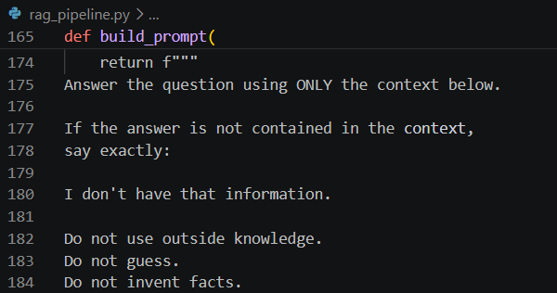
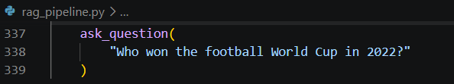
Output:
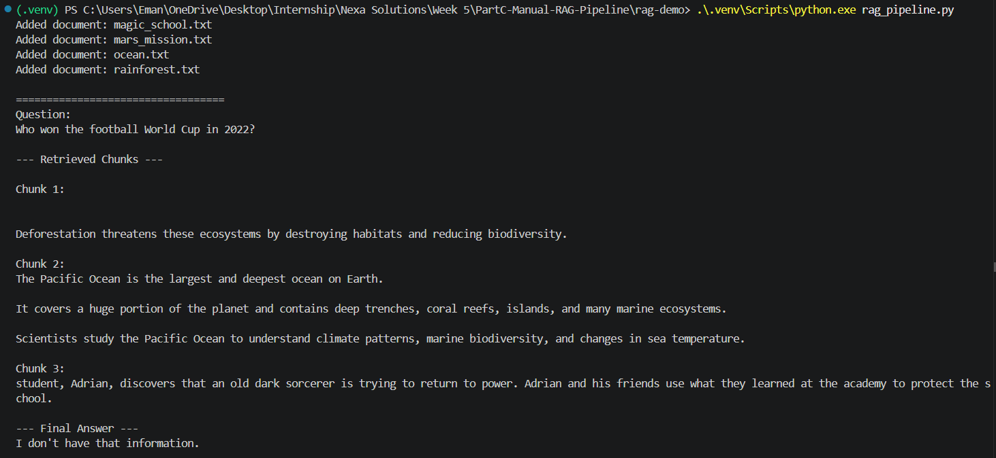

Source Attribution
Code:
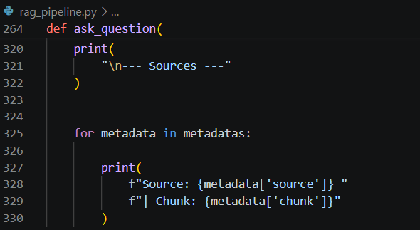
Output:
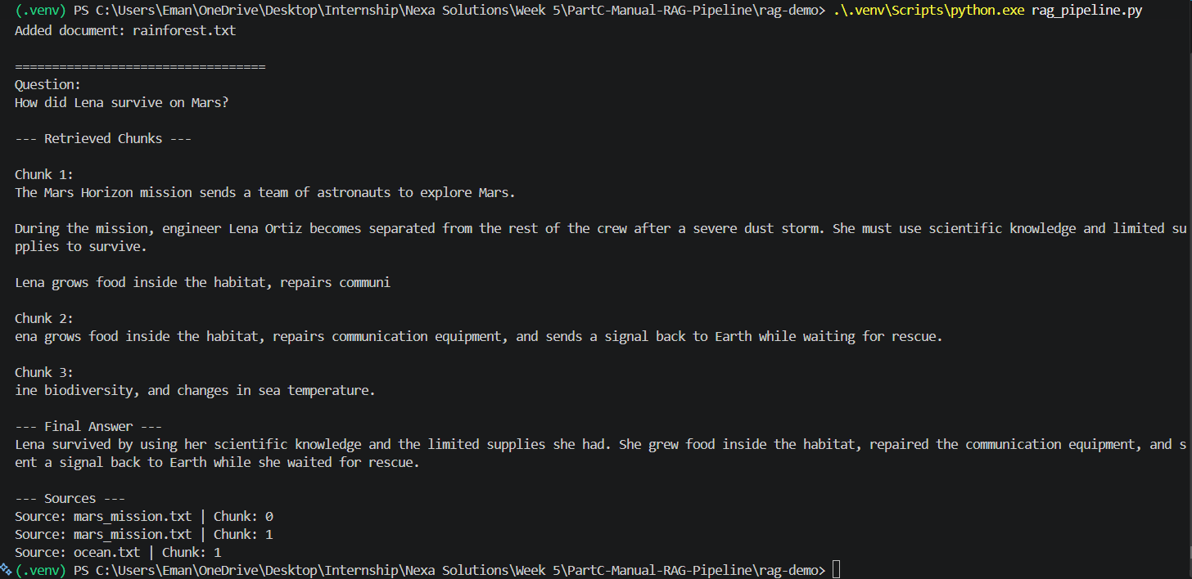

PART D: RAG QUALITY & HALLUCINATION REDUCTION

Exercises:-

Build a Table of 5 Test Questions
Code:
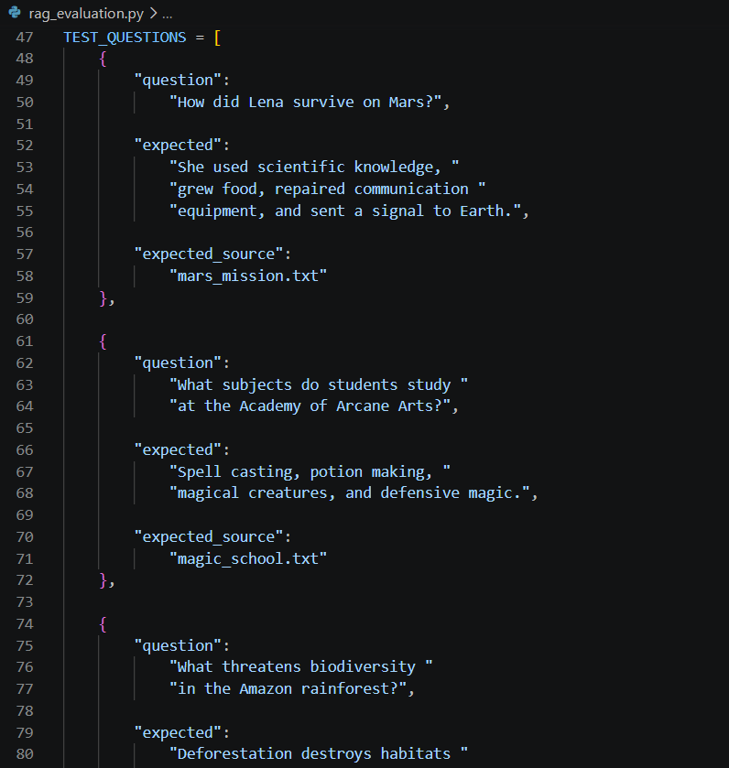
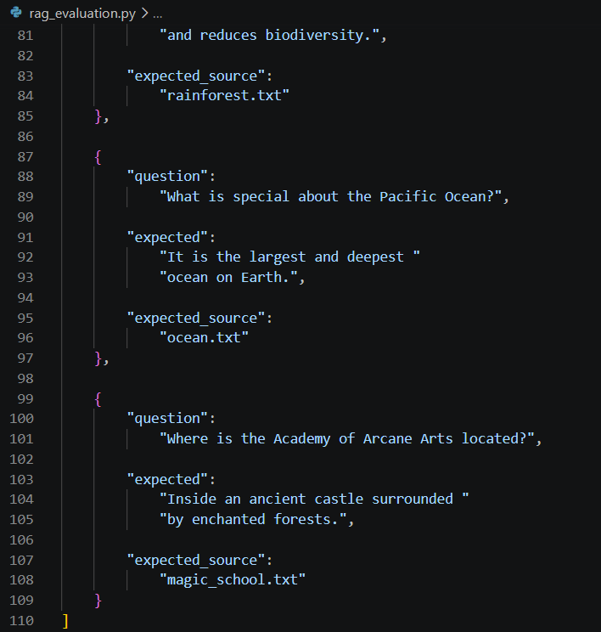
Output:
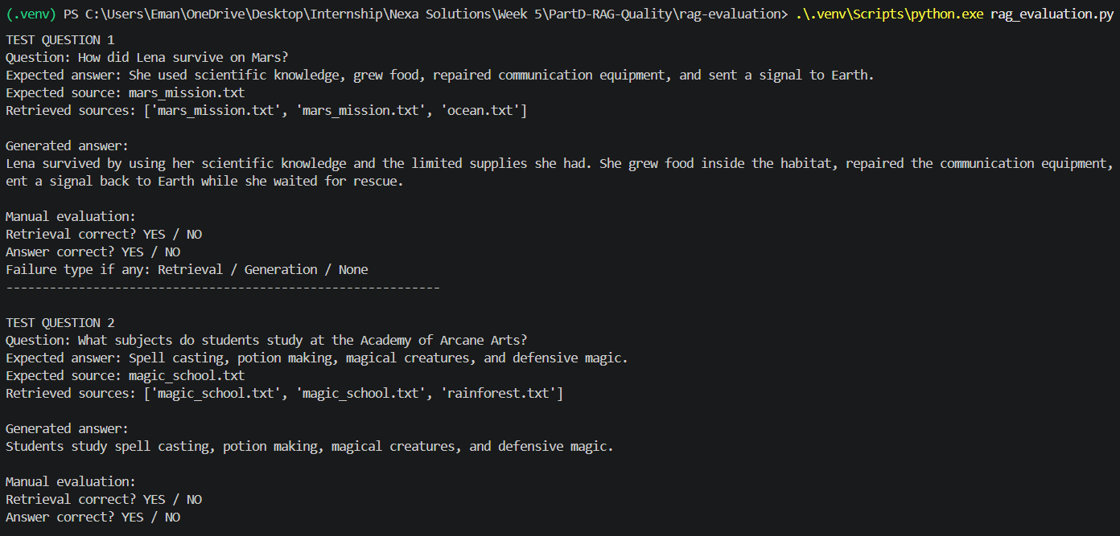
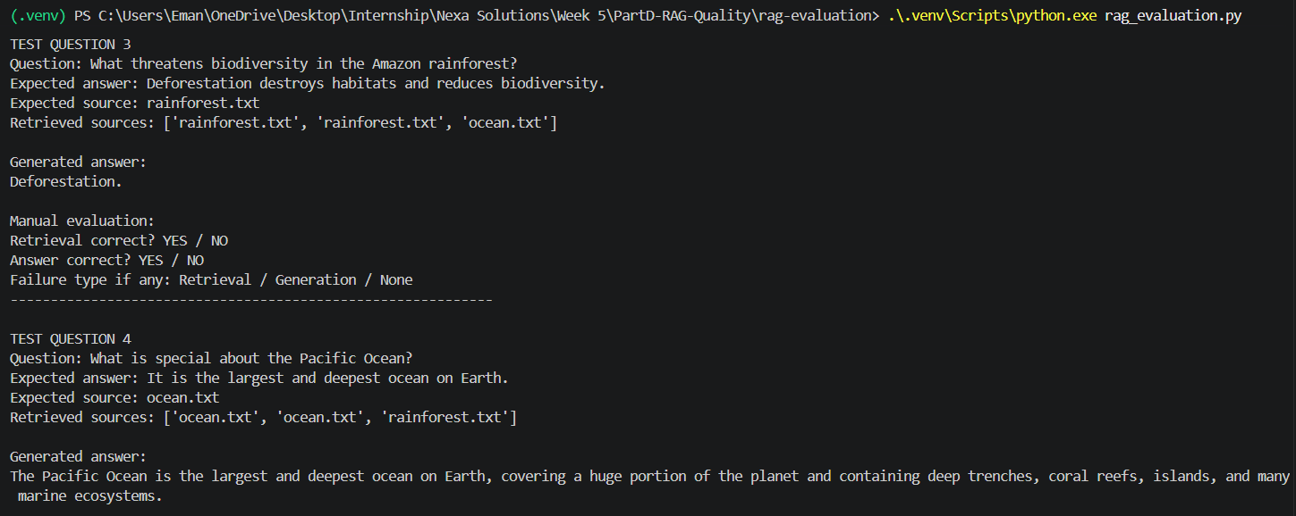
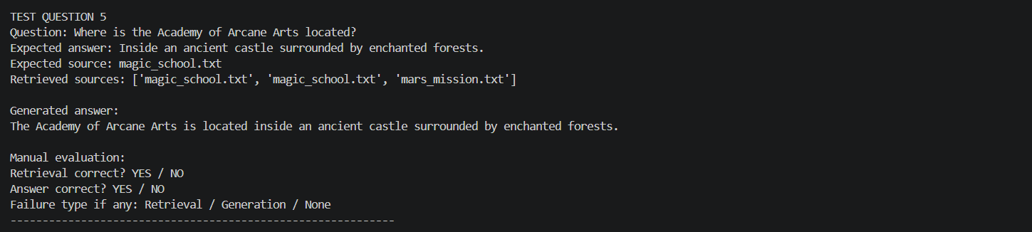
Table:
No. | Question | Expected Answer | Expected Source
1 | How did Lena survive on Mars? | Used science, grew food, repaired communication equipment, sent a signal to Earth | mars_mission.txt
2 | What subjects do students study at the Academy? | Spell casting, potion making, magical creatures, defensive magic | magic_school.txt
3 | What threatens Amazon biodiversity? | Deforestation | rainforest.txt
4 | What is special about the Pacific Ocean? | Largest and deepest ocean on Earth | ocean.txt
5 | Where is the Academy located? | Ancient castle surrounded by enchanted forests | magic_school.txt

Evaluate Retrieval and Answer Quality
Code:
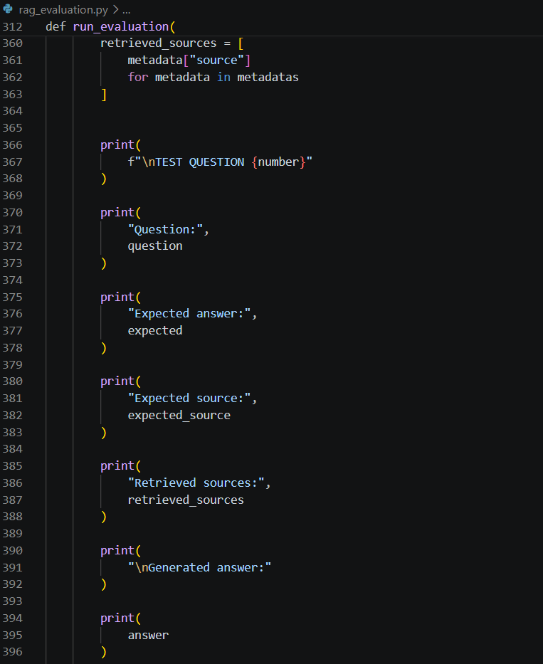
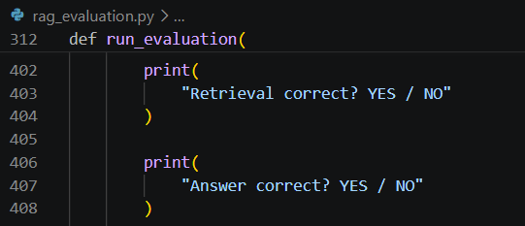
Output:
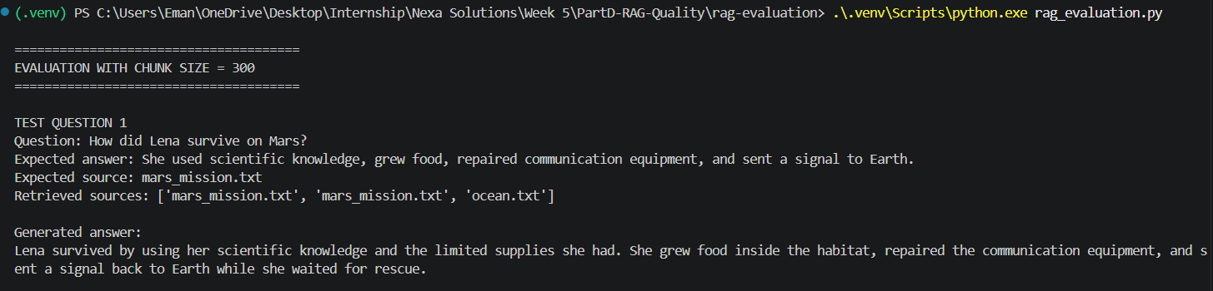
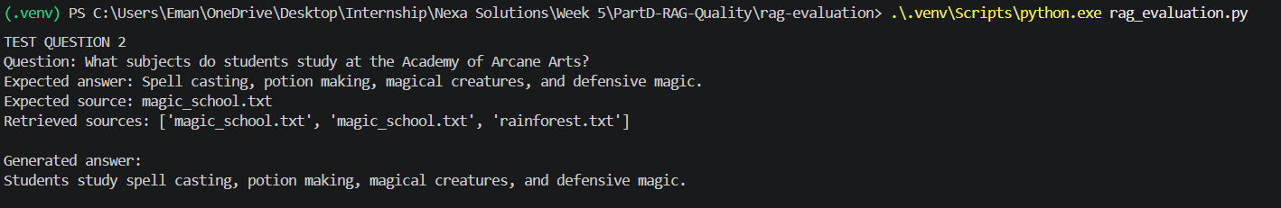
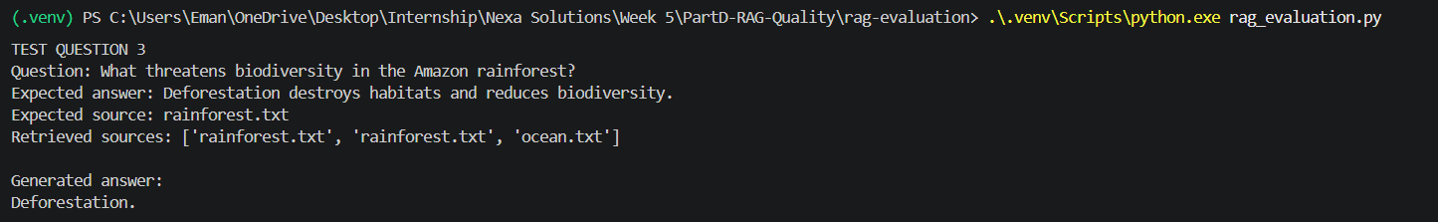
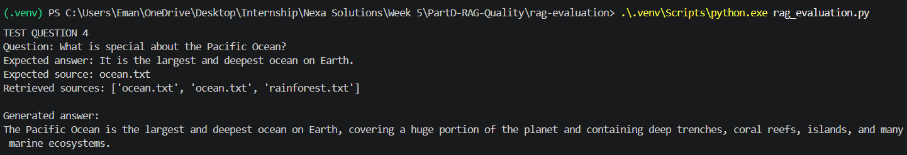
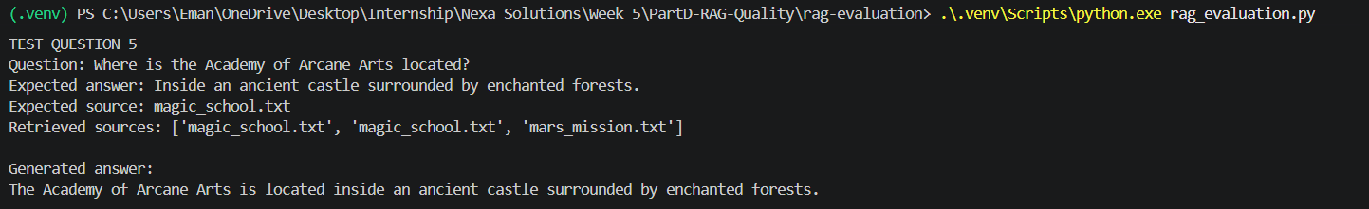

Table:
Question | Retrieval Correct? | Answer Correct?
Q1 | Yes | Yes
Q2 | Yes | Yes
Q3 | Yes | Yes
Q4 | Yes | Yes
Q5 | Yes | Yes

Diagnose Retrieval vs Generation Failures
Code:
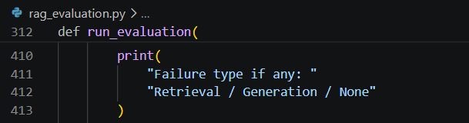
Output:
Table:
Question | Failure? | Failure Type | Explanation
Q1 | No | None | Expected and actual answer match
Q2 | No | None | Expected and actual answer match
Q3 | No | None | Expected and actual answer match
Q4 | No | None | Expected and actual answer match
Q5 | No | None | Expected and actual answer match

Halve the Chunk Size and Compare Results
Code:
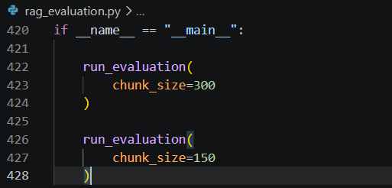
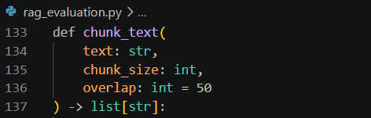
Output:
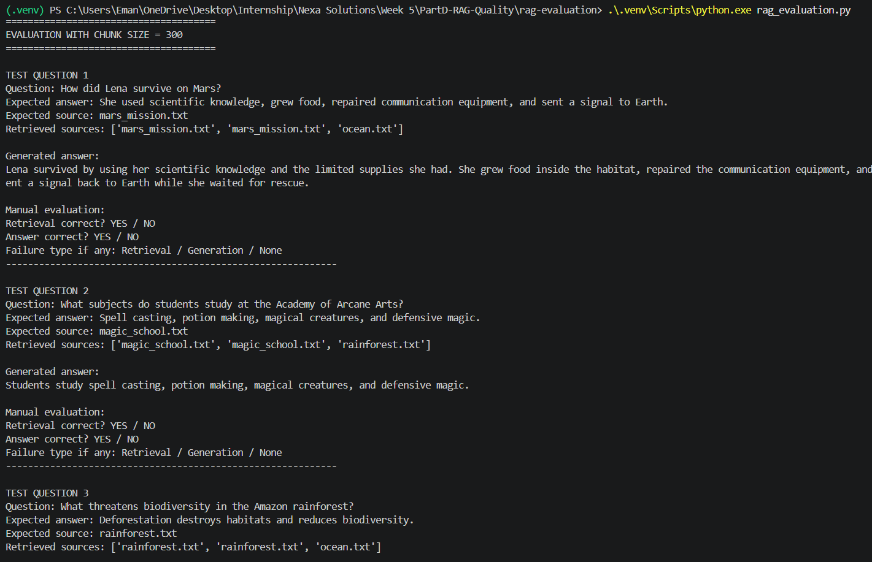
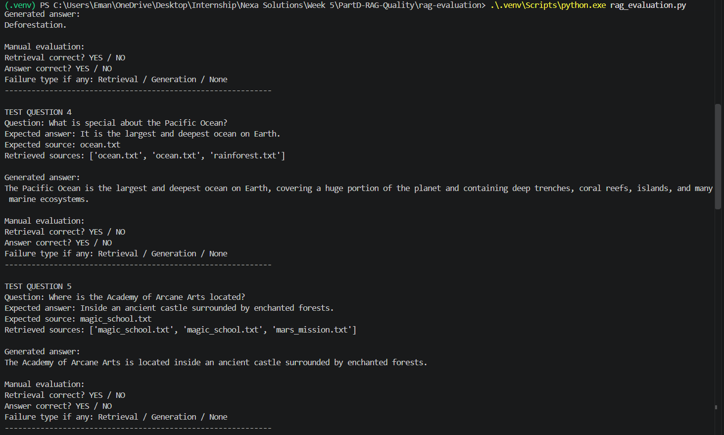
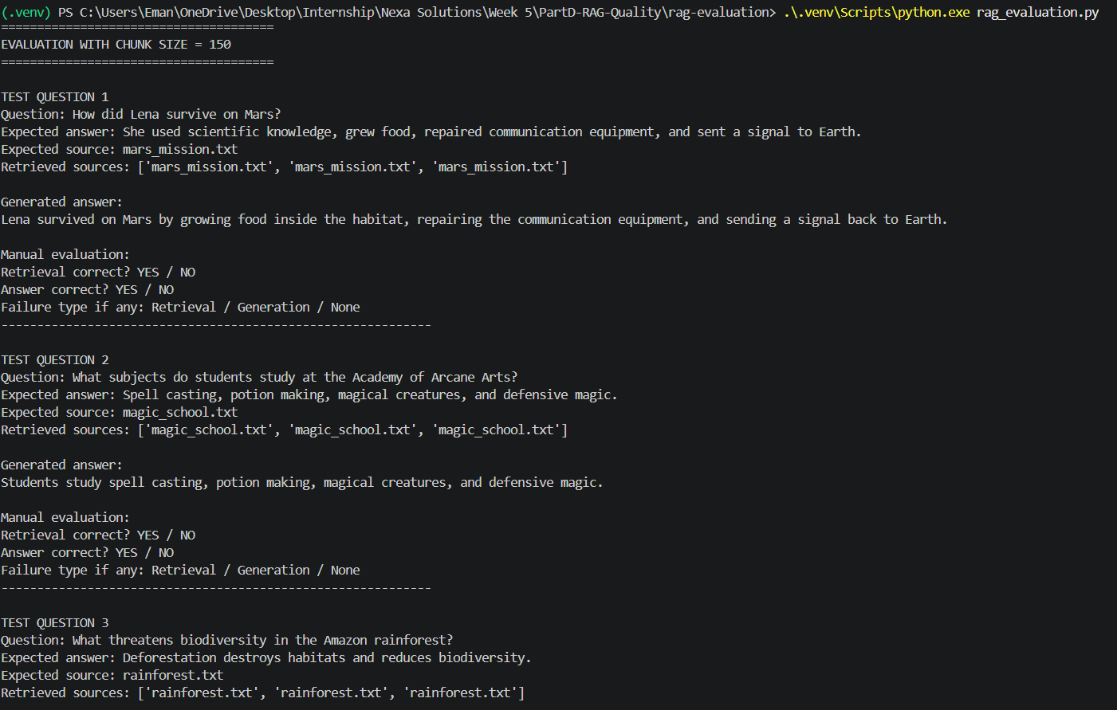
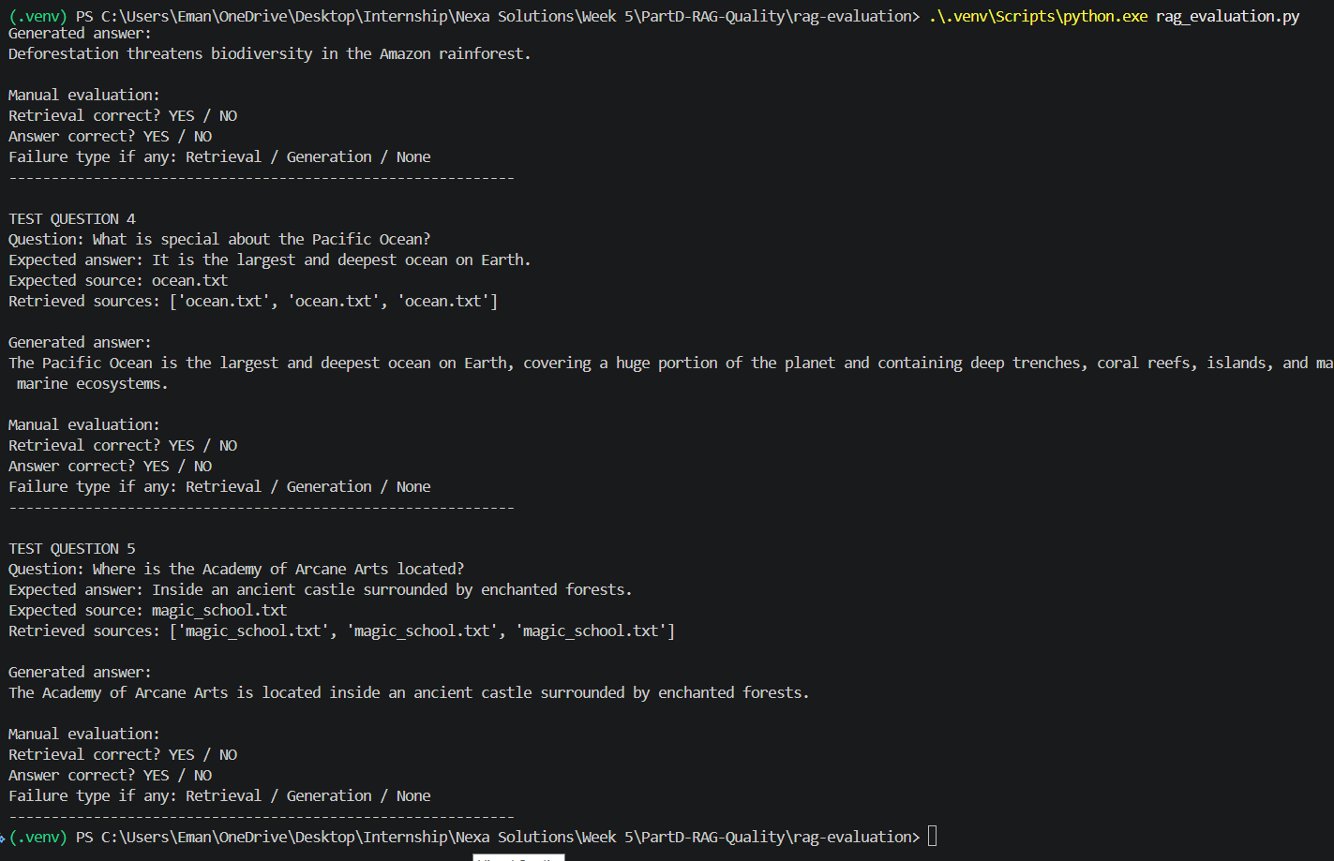

Table:
Question | Chunk 300 Retrieval | Chunk 300 Answer | Chunk 150 Retrieval | Chunk 150 Answer | Result
Q1 | Yes | Yes | Yes | Yes | Improved
Q2 | Yes | Yes | Yes | Yes | Improved
Q3 | Yes | Yes | Yes | Yes | Improved
Q4 | Yes | Yes | Yes | Yes | Improved
Q5 | Yes | Yes | Yes | Yes | Improved

PART E: ADDING A /ask ENDPOINT TO THE FASTAPI SERVICE

Exercises:-

Test /ask with an Answerable Question
Code:
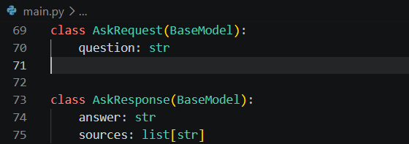
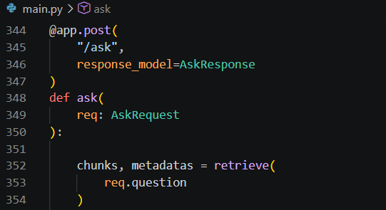
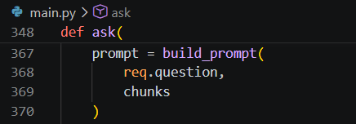
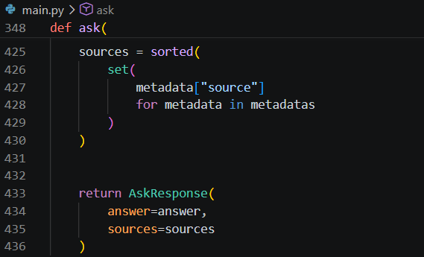
Output:
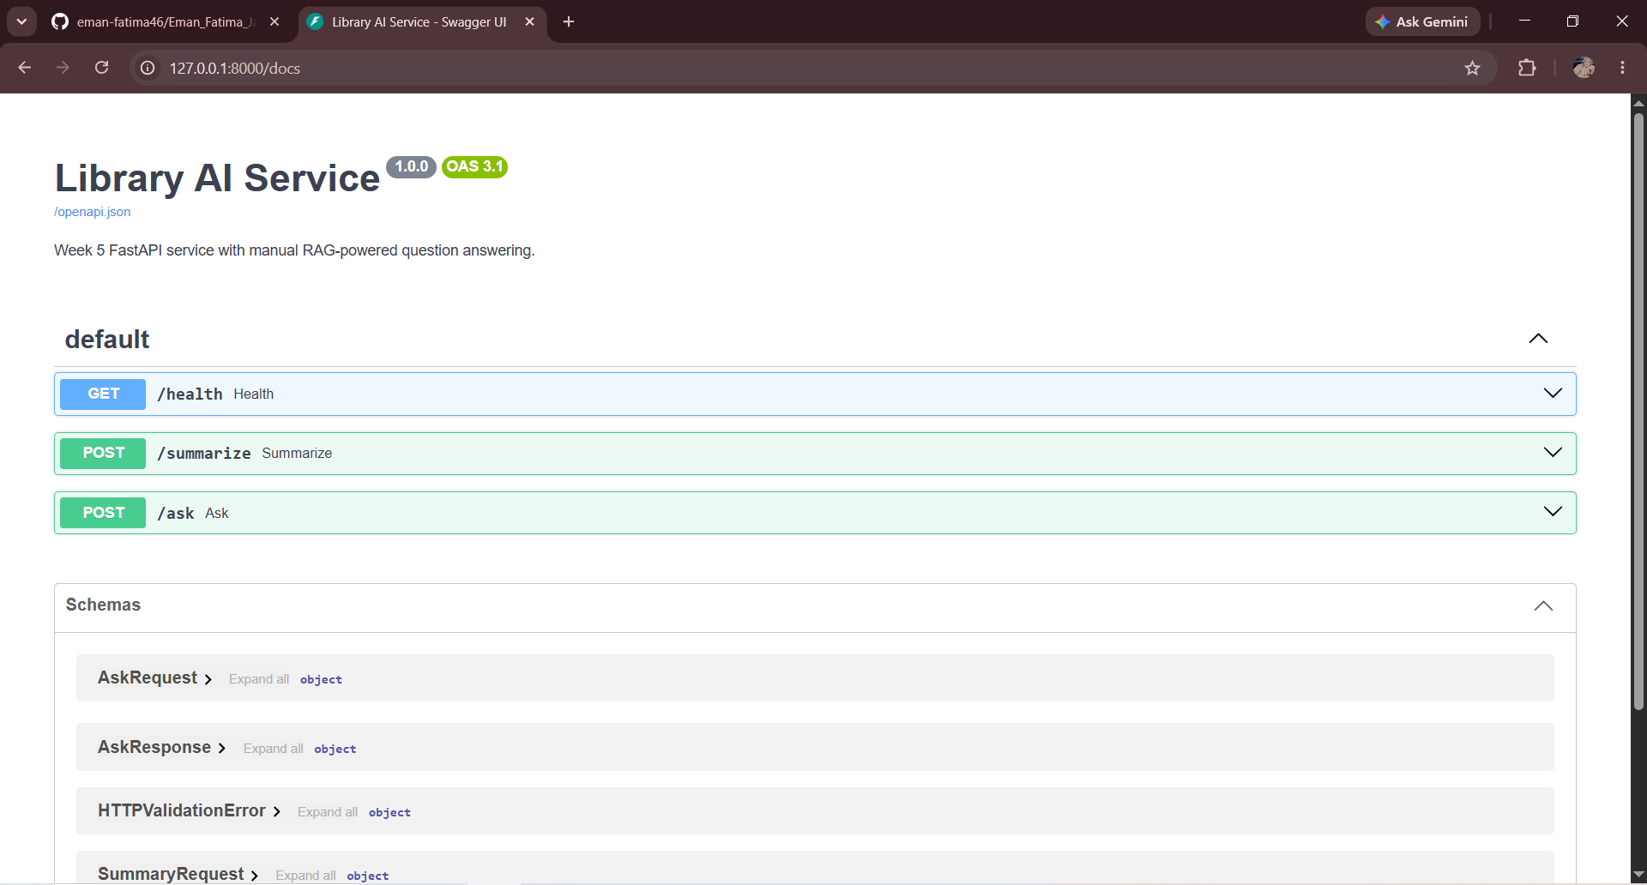
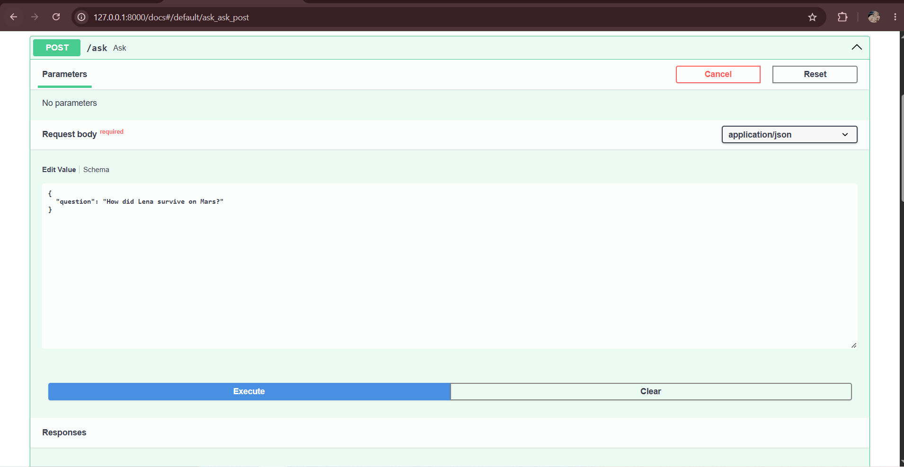
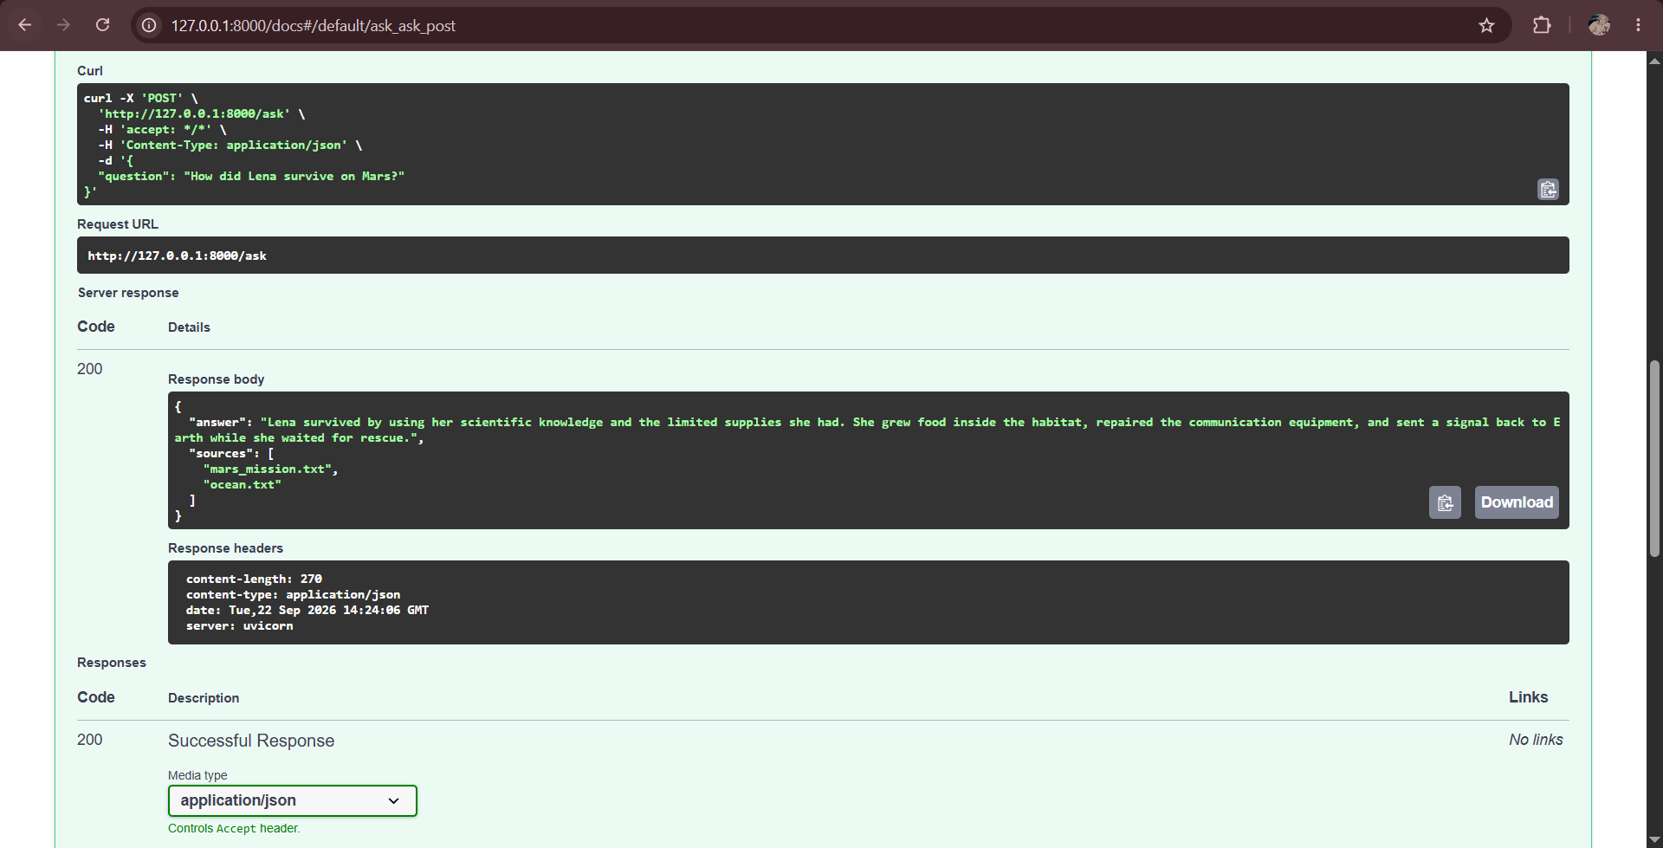

Add Clean LLM Error Handling
Code:
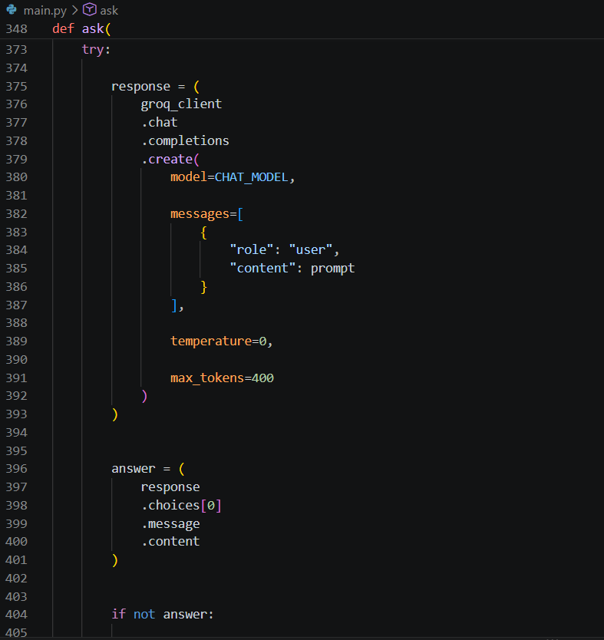
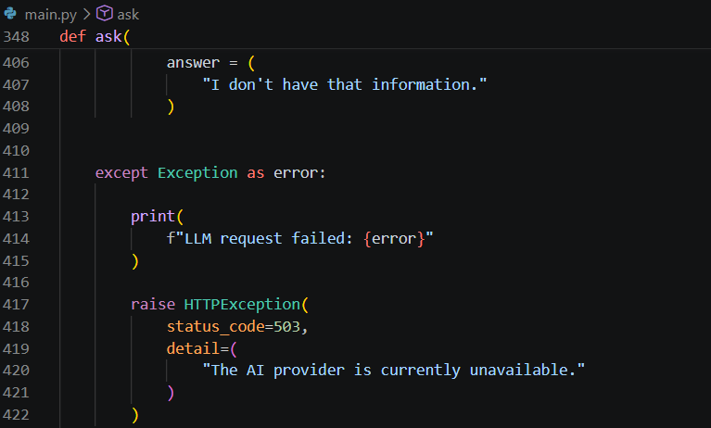
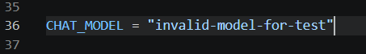
Output:
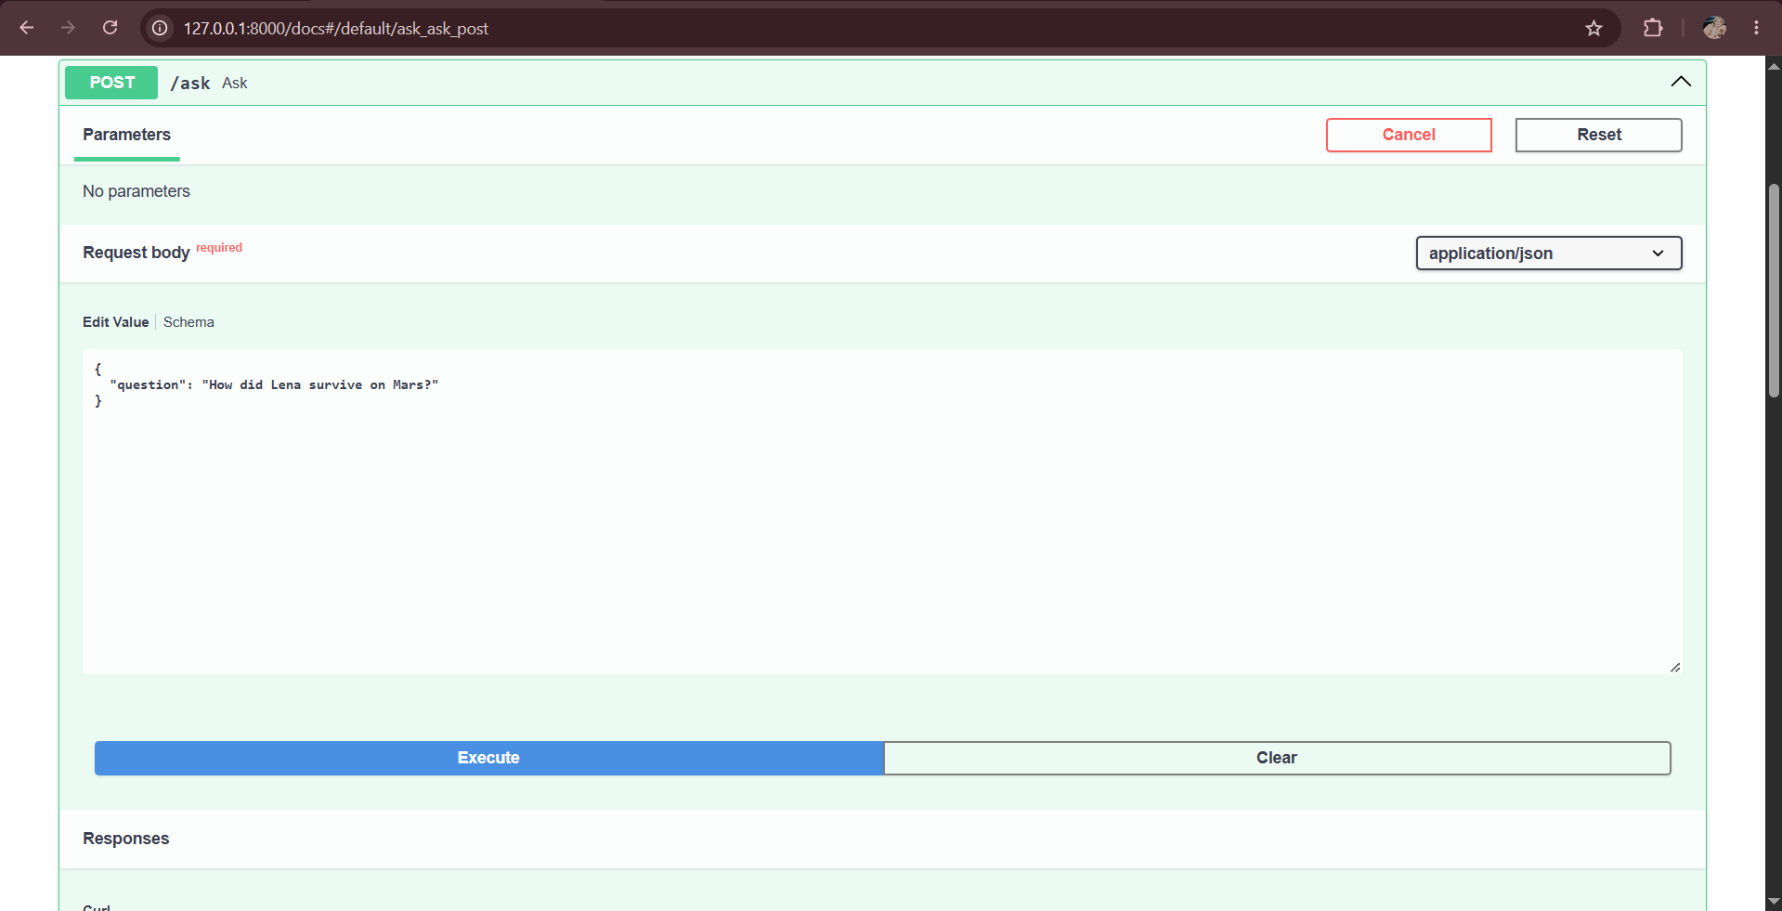
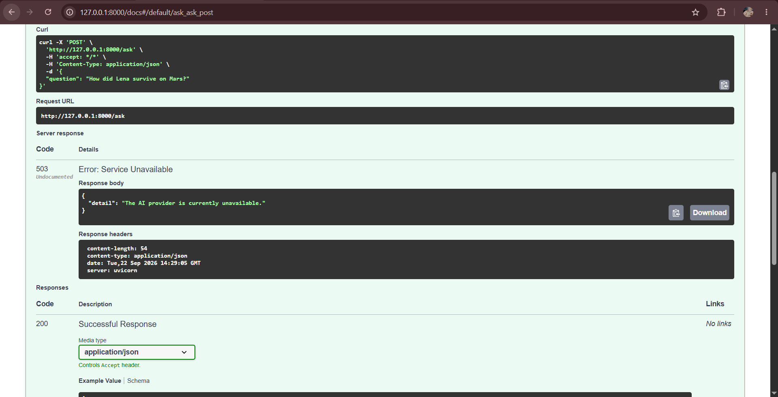

PART F: GIT: SAFELY UNDOING A COMMIT (git revert)

Exercises:-

Creating an Intentional Bad Commit
Code:
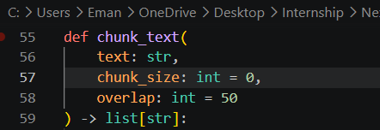
Output:

Reverting the Bad Commit and Verifying the Reverted File
Code:
Output:
Code:
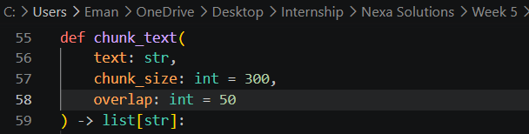
Output:
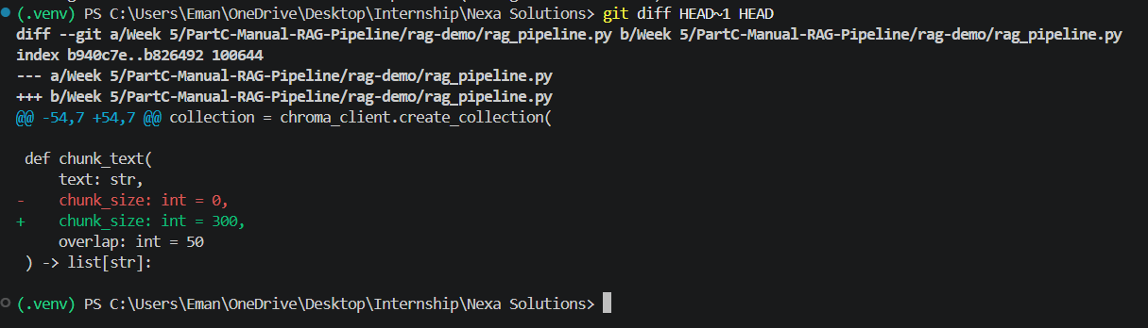

Verifying Git History
Code:
Output:
